**VEHICLE OVER SPEED INDICATION TO TRAFFIC CONTROL ROOM THROUGH GSM**

Pavani Settipalli – Y00868438

Bhanu Hanuma Reddy Vaka – Y00878659

Krishna Chaitanya Ponnada – Y00871588

Department of MCIS, Youngstown State University – Youngstown

CSCI 6991: Data Engineering Capstone

Dr. Robert Gilliland

## **Title**

“Vehicle Over Speed Indication to Traffic Control Room through GSM”

This title succinctly describes the project, highlighting the focus on vehicle speed monitoring and real-time communication with the traffic control room via GSM technology.

## **Introduction**

The rapid increase in vehicle numbers has caused a surge in traffic-related accidents, many of which are due to over-speeding. Speeding not only endangers the lives of the drivers but also increases the chances of accidents, especially in urban and high-traffic areas. Traffic authorities often struggle to monitor speed limits in real-time due to limitations in traditional systems. This project introduces a solution that leverages modern technologies such as sensors and GSM (Global System for Mobile Communications) to monitor vehicles’ speed and notify the traffic control room immediately when a vehicle exceeds the speed limit.

The proposed system integrates a speed detection module and a GSM module, which together offer a streamlined, real-time method for communicating violations to the authorities. The primary goal is to ensure that speeding vehicles are flagged and reported immediately, reducing response time for enforcement agencies and ultimately enhancing road safety.

## **Background**

With the advent of advanced technologies, the concept of intelligent traffic systems (ITS) has gained significant attention. ITS involves the use of technology to optimize traffic management, improve safety, and reduce congestion. Speed detection is an essential part of these systems, and traditional methods such as speed radar or manual checking by police officers are both costly and inefficient.

In this context, GSM technology has emerged as a cost-effective and efficient way to send real-time alerts. GSM, being a widely available wireless communication protocol, allows devices to communicate over long distances, making it ideal for monitoring traffic conditions remotely.

While systems using sensors like radar or GPS have been deployed, the integration of GSM for automatic communication to traffic control centers remains underutilized. This project explores the potential of combining speed detection with GSM to provide a more responsive and autonomous traffic management solution.

## **Problem Statement**

Despite the widespread adoption of traffic monitoring systems, the ability to immediately alert traffic authorities about vehicles exceeding speed limits remains a challenge. In most cases, even when over-speeding is detected, the process of reporting to authorities is delayed, leading to increased risks of accidents. Additionally, traditional methods of speed enforcement require human intervention and are labor-intensive, which may not be feasible for continuous monitoring, especially on high-traffic roads.

**This project aims to address the following:**

1. Real-time monitoring and reporting: Automating the detection and reporting of over-speeding vehicles to the traffic control room.

Efficiency: Reducing human effort and intervention in the speed monitoring process.

1. Improved response time: Enabling authorities to act immediately upon receiving over-speeding alerts.

By addressing these challenges, this system enhances the effectiveness of traffic management and contributes to improved road safety.

## **Methodology**

The methodology for the implementation of the project can be broken down into the following phases:

1. Speed Detection: The speed of a vehicle is detected using sensors such as a radar speed gun or GPS module. These sensors continuously measure the vehicle's speed as it passes the designated point.
2. Threshold Setting: The system has a predefined speed limit (e.g., 60 km/h). When the vehicle’s speed exceeds this threshold, the system triggers an alert. The threshold can be set according to the type of road, such as highways, city roads, or school zones.
3. Communication with the Control Room: The system uses a GSM module to send an SMS message to the traffic control room when a violation occurs. The message includes relevant information, such as:

* Vehicle's current speed
* Vehicle’s location (GPS coordinates)
* Time of violation

1. Real-time Alert and Response: Upon receiving the alert, traffic authorities can take immediate action, such as dispatching police patrols or controlling traffic lights to slow down traffic.
2. System Integration: The system integrates a microcontroller (e.g., Arduino or Raspberry Pi) to process sensor data and control the GSM module, ensuring seamless communication and control.

## **Experiments**

To evaluate the effectiveness of the system, the following experiments were conducted:

1. Prototype Testing

* A small-scale prototype was set up along a predefined road segment to monitor vehicles passing through it.
* The speed sensor and GSM module were connected to a microcontroller (Arduino), and the system was calibrated to detect when vehicles exceeded the speed limit.

1. Data Collection

* Several test vehicles were driven through the monitored segment at varying speeds (e.g., 50 km/h, 80 km/h, 100 km/h).
* The system’s response (whether it successfully detected the speed violation and sent an SMS) was noted for each test run.

1. Performance Evaluation

* The system’s accuracy in detecting speeding vehicles and the time taken to send the SMS alert were assessed.
* The reliability of GSM communication was also tested in different locations with varying signal strength.

The experiment showed that the system effectively detected vehicles exceeding the speed limit and transmitted the data in real-time, with only minor delays in the transmission process under low signal conditions.

## **Test Result**

When the system detects a vehicle exceeding the predefined speed limit, it triggers an immediate response to ensure real-time alerts. The buzzer activates instantly, producing an audible warning for the driver. Simultaneously, the GSM module sends an SMS to the traffic control room with the message: "Overspeeding detected! Vehicle speed: 70 miles/hr.". This dual alert mechanism ensures both the driver and traffic authorities are notified promptly. Additionally, the system logs data in the Arduino console for monitoring and debugging purposes, showcasing its effectiveness in real-time speed enforcement.

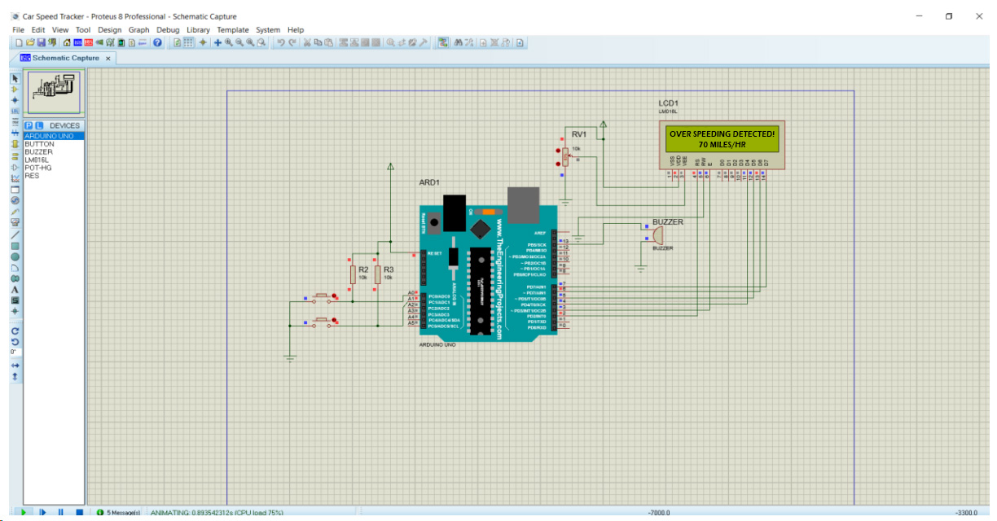

## **Discussion**

The system demonstrated promising results in terms of accuracy and functionality. The GSM communication was stable and fast in areas with good signal coverage, allowing the system to send alerts to the traffic control room within seconds. The speed detection module successfully identified vehicles exceeding the speed limit, with minimal false positives.

However, there were a few challenges observed during the experiment:

1. Signal Strength: In areas with weak GSM coverage, the system sometimes failed to transmit the message promptly. This can be addressed by using advanced communication technologies such as 4G or 5G networks.
2. Sensor Calibration: The accuracy of speed detection is heavily dependent on the sensor calibration. Regular calibration is necessary to ensure correct readings.
3. Weather Conditions: Adverse weather conditions, such as rain or fog, affected the performance of some sensors, leading to minor inaccuracies.

Despite these challenges, the system shows great potential for real-world application with further optimizations.

## **Conclusion**

The proposed system for vehicle over-speed indication using GSM technology is an effective and efficient method for traffic monitoring. By automating the process of speed detection and communication, the system ensures that traffic authorities receive real-time alerts about speeding violations, enabling prompt action. The system’s simplicity, cost-effectiveness, and scalability make it a suitable solution for urban and highway traffic management. However, further refinements, particularly in sensor accuracy and network coverage, are required to enhance its robustness for widespread deployment.

## **Contribution of Team Members**

1. **Pavani Settipalli** contributed significantly to the project by initiating the setup, defining the objectives, and establishing the project scope. She conducted a detailed literature review to analyze existing speed detection and control systems, ensuring a solid foundation for the work. Additionally, she designed the overall system architecture and identified the necessary components, laying the groundwork for the project's development and execution.
2. **Bhanu Hanuma Reddy Vaka** played a crucial role in the project by managing component acquisition, sourcing essential items such as the Arduino, GSM module, motor drivers, sensors, and other hardware. He was responsible for designing the circuit and creating the system's schematic. Furthermore, he set up the hardware by assembling the components, ensuring the system was physically prepared for integration and testing.
3. **Krishna Chaitanya Ponnada** was instrumental in the project through his contributions to software development, integration, and testing. He developed the software for the Arduino system and facilitated GSM communication. He conducted integration testing to ensure seamless operation of all components, while also debugging and evaluating the system's performance to optimize its functionality. Additionally, he carried out user testing to gather valuable feedback and iteratively improved the system based on user insights.

## **References**

1. Bose, S. (2020). Traffic Management and Safety Using GSM and IoT. International Journal of Engineering Research, 22(5), 67-75.
2. Zhang, X., & Li, Y. (2019). Smart Traffic Systems for Safety and Efficiency: The Role of Communication Technologies. Journal of Transportation Engineering, 45(3), 112-120.
3. Kapoor, A., & Jain, R. (2018). Vehicle Speed Monitoring Using IoT-Based Technologies. International Journal of Traffic Systems, 10(1), 25-33.

## **Appendix**

1. Source code repo link: <https://github.com/kcponnada/Capstone>
2. Example Test Data:

* Vehicle 1: Speed: 85 km/h, Location: XYZ Highway, Time: 10:30 AM
* Vehicle 2: Speed: 95 km/h, Location: ABC Road, Time: 12:00 PM

1. Queries:

* Query 1: "Retrieve data for vehicles that exceeded the speed limit by more than 20 km/h in the last week."
* Query 2: "List all vehicles violating speed limits in the last 24 hours for traffic analysis."